**Leader Overview**

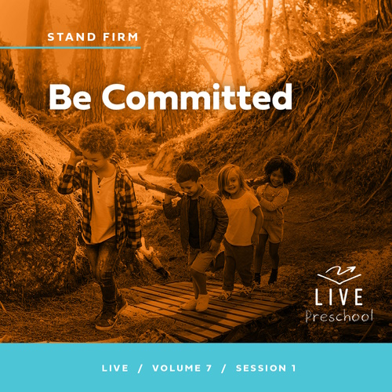

**Volume Overview**

**Stand Firm**

*The world thinks of power as action. Powerful people are able to take control, able to change things. But Jesus blessed the meek, the hungry, and the poor. There is a power this world overlooks. There is power in standing firm in faith. Christians have long stood their ground, not to gain this world’s power but as witnesses to a better world to come. So we stand strong, committed, and bear witness to the world.*

**Session Overview**

**Be Committed**

*In this* **Live** *session, preschoolers will discover God gives them strength to serve Him no matter what situation they’re experiencing. Preschoolers will explore the story of Stephen standing firm while being questioned by those who wanted to silence Jesus’ followers. This amazing story will show them that they can speak Jesus’ truth even when facing the toughest circumstances and that Jesus will stand with them.*

**Bible Lesson**

Stephen Is Persecuted for His Faith

[Acts 6:2–15](https://ref.ly/logosref/Bible.Ac6.2-15); [7:51–60](https://ref.ly/logosref/Bible.Ac7.51-60)

**Faith Fact**

I will serve God no matter what.

**Faith Verse**

[Ephesians 6:13](https://ref.ly/logosref/Bible.Eph6.13) (NLT)

Put on every piece of God’s armor so you will be able to resist the enemy in the time of evil. Then after the battle you will still be standing firm.

**Preparing for the Session**

**Leader Preparation Time: 20–25 Minutes**

|  |
| --- |
| ***You Will Need***  ***Preservice Activities***  *• Toys*  *•* ***Preservice Bible Story Warm-Up Page***  *• Scissors*  *• Pretzel sticks*  *• Bear-shaped gummies*  *• Hand sanitizer*  *• Napkins, one per kid*  ***Large Group***  *• Bible*  *• Worship songs (Song suggestions: “Movin’ Me” Lyric Video by Amber Sky Records; “Living Color” Lyric Video by Elevation Church Kids; “See a Victory” Lyric Video by Elevation Church Kids)*  *• For groups not using a phone or tablet only, add:*  *• Projector or TV*  *• Laptop*  *•* ***Faith Fact Sound*** *video (bell ringing)*  *•* ***Faith Fact Slide***  *•* ***Faith Verse Slide***  *•* ***Faith Verse Video***  *•* ***Bible Lesson Video A***  *•* ***Bible Lesson Video B***  ***Small Group***  *• Paper plate or bowl, one per group*  *•* ***Small Group Activity Page****, one per kid*  *• Pencils or pens, one per kid*  *• Crayons or markers*  *• Optional: Cones or floor-safe tape to mark off play space*  *• Marbles or coins, one per kid*  *• Clear plastic bowl, one per group*  *• Water*  *• Larger pan under bowl in case of spillage*  *To access session content and videos from a computer, visit:* [***BibleEngagementProject.com/downloads***](https://bibleengagementproject.com/downloads) |
| ***Getting Ready***  ***Preservice Activities***  *• Set out toys and snacks.*  *• Print and cut apart the* ***Preservice Bible Story Warm-Up Page****.*  ***Large Group***  *• Download videos and slides if needed.*  *• Select worship song(s) and have them ready to play.*  ***Small Group***  *• Print copies of the* ***Small Group Activity Page****, one per kid*  *• Optional: Place cones or use floor-safe tape to create a play space. This should include a start and stop line as well as boundaries to stay within.*  *• Fill the bowl with water.*  ***First time leading* Live *for Preschool? Check out the*** [**Facilitator Guide**](https://0b769b0ed3569ef9d18b-f88d8272f61086866d50d048b43ef630.ssl.cf2.rackcdn.com/sites/biblengagementproject/Listen_Facilitator_Guide.pdf)**.** |

**Preservice Activities**

*See what’s needed at the beginning of the session.*

**Bible Story Warm-Up**

How many of you like to go places? (*Group response)* I’ll show you a few pictures, and I want you to call out what you see.

• *Show each picture one at a time. Allow kids to call out what is in the picture.*

Wow, those were some great answers! In each of the pictures, there were things you could notice. The thing that stuck out the most to me was something that every picture had—a path of some kind. I saw a road, a sidewalk, steps, and a trail. All those things help you know where to go. As easy as it can be for us to follow those paths, someone had to plan and make them for us. It’s pretty amazing when you think about how many paths there are that guide us.

Have you ever walked down a sidewalk? How about a trail?

When you went on the trail, how did you know where to go?

What are some other things that help you know where to go?

In the Bible, we learn that it’s not only about what we follow but also who we follow. God is the One we should follow. The more we read our Bible, the easier it is to know how to follow Him. In our Bible story, we’ll learn about a man who followed and served God no matter what happened in his life. I’m so excited that we get to learn together today.

**Snack**

**Pretzel Sticks and Bear-Shaped Gummies**

We have a fun snack for you today. It’ll require a little bit of creativity and teamwork. Before we get started, let’s all clean our hands.

• *Use hand sanitizer to clean kids’ hands.*

Terrific! Now that your hands are clean, let’s begin. First, you’ll open up your napkin and make it as big as possible.

• *Give each kid a napkin.*

• *When their napkins are open, give each kid a handful of pretzel sticks and a bear-shaped gummie.*

Now, each of you can lay out your pretzels on your napkin to make a path. You can choose any kind of path that you want. Just make it wide enough for your bear to walk down.

• *Allow kids time to make a path.*

• *Be ready to help kids pair up, so they can complete the next part of the activity.*

I love seeing all the creativity in the different kinds of paths that you made. After you make your path, the person next to you gets to use your path for their bear to go down. Let’s see if they can follow your path all the way to the end.

Now remember, when you move your bear down the path, be very careful not to crash into any of the pretzels. Can you do that? *(Group response)*

• *Allow kids time to do the activity.*

• *When they’re done, they may eat their snack.*

Did you have more fun making the path or taking your bear down a path? *(Allow responses.)* The best part about this activity was that you couldn’t do it by yourself. You each had to take the time to create a path for someone else to use. That’s called serving others. When we put the needs of someone else first, we’re serving them. Jesus was the very best Servant. Today, we’ll learn how we can be more like Him through a Bible story about a man named Stephen.

**Free Play**

*Any extra time can be spent playing with toys.*

**Transition**

*A few minutes before service begins, have kids make their way to the large group area and sit in their designated areas.*

**Large Group**

**25 Minutes**

*See what’s needed at the beginning of the session.*

**Introduction**

Hi, kids! I’m so excited to be here with you today! We’ll have so much fun exploring God’s Word together. *(Hold up the Bible.)* If you’re excited to be here, raise your hand! *(Group response)*

Today, we’ll learn about Stephen, a man who helped in the church and gave food to people who were hungry. Even though Stephen was helping people, not everyone liked him. When people told lies about Stephen, he told them the truth about Jesus. Stephen served God even though he was in a tough situation, and God was with Stephen.

**Faith Fact**

We can be like Stephen. We can help others and serve God no matter what comes our way. Our Faith Fact today is **I will serve God no matter what.**

• *Show the* ***Faith Fact Slide.***

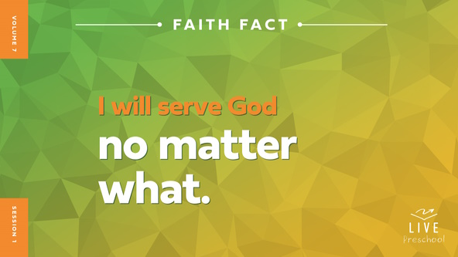

Let’s say our Faith Fact together. The first time we say it, let’s whisper it quietly. **I will serve God no matter what.** *(Group response)* Awesome! This time let’s shout it! **I will serve God no matter what**. *(Group response)*

**Bible Time**

That was so great! You have big voices. Now we’ll use another part of our bodies as we explore the Bible. Let’s see if you can guess what I’m talking about. You have two of them. They’re on your head. Point to them if you can guess what I’m talking about. They help you listen and hear. Did you figure it out? *(Point to your ears.)* Yes, let’s turn up our listening ears as we check in with Lizzy.

• *Play* ***Bible Lesson Video A****.*

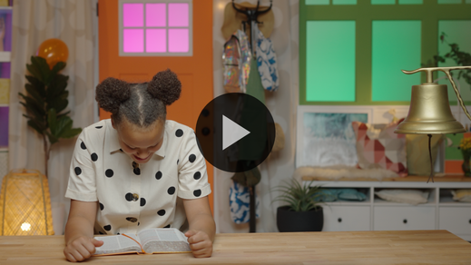

I’m glad Grandpa gave us a little time to think! It’s time to worship now. Then, we’ll come back to talk about what’s going to happen next in our Bible story.

**Worship**

I love exploring God’s Word with you. I also love worshipping God with you. We show God how much we love Him when we listen to His Word and worship Him. If you’re ready to focus on God and tell Him that you love Him, give me a huge thumbs up. *(Group response)*

**Praise**

Who wants to thank Jesus for loving us? Touch your toes down low. *(Group response)*

Do you know Jesus is always with you? Spin around. *(Group response)*

Who wants to show Jesus how much you love Him? Wave your hands up high. *(Group response)*

**Sing**

I heard what great big voices you have when we said our Faith Fact. One way to worship God is by singing, and I want to hear those strong voices now while we worship God together. Let’s sing!

• *Lead the kids in singing one or two songs. See song suggestions at the beginning of the session.*

**Prayer**

We have so many things to thank God for. Let’s bow our heads and talk to God.

|  |
| --- |
| *Dear God, we thank You for the gift of Your love. We praise You for who You are. You are so big and strong, and yet You care for the youngest, the oldest, and everyone in between. Please speak to us as we continue to learn Your truth. Amen.* |

**Bible Time cont’d**

• *Start* ***Bible Lesson Video B*** *and pause on the image of the two choices.*

I think Grandpa and Lizzy will be back soon! Let’s think about the answer to what happens next. Put on your thinking caps *(demonstrate).* What do you think? Did Stephen tell the truth about Jesus even if it made people mad? *(Point to “Jesus” graphic.)* Or did Stephen not say the truth? *(Point to “Jesus with red X” graphic.)*

• *Have kids do the following actions.*

If you think Stephen spoke the truth, put your hands around your mouth like you have a megaphone *(demonstrate)*. If you think Stephen didn’t say the truth, put your hands over your mouth so you can’t speak *(demonstrate)*. Ready? Choose your answer.

• *Pause while kids respond.*

Let’s find out if you’re right! Let’s check back in with Lizzy and Grandpa.

• *Play* ***Bible Lesson Video B.***

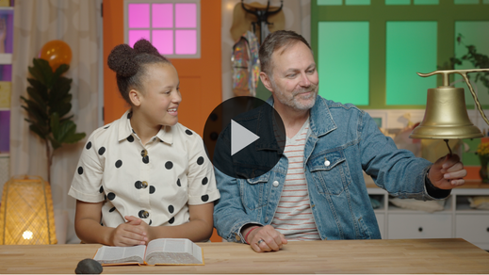

Wow, Stephen was so brave and strong! What was your favorite part of this Bible story? *(Allow responses.)* I love that you remembered things from our Bible story. It’s so important to remember that even though Stephen was hurt and suffered, God was with him. God never leaves us or gives up on us no matter what we’re going through.

**Response Time**

*Play a worship song quietly.*

Let’s respond to what we’ve learned today. Show me your strongest muscles. *(Demonstrate showing your bicep muscles.)* Those muscles look very strong, but God is so much stronger. When He asks us to serve Him, He helps us to be so much stronger than we ever can be on our own. Look at your muscles and imagine them ten times bigger. God’s strength is even bigger. Now, look at your muscles and imagine them a hundred times bigger. God’s strength is even greater than that. Let’s pray and thank God for the strength that He gives us.

• *Have the kids repeat phrases of the prayer after you.*

|  |
| --- |
| *Dear God, thank You for Your strength. I know You never give up on me. You promise to work through me. I want to serve You no matter what. Amen.* |

**Faith Verse**

Do you know what helps us to stand strong? Knowing God’s Word, the Bible. Let’s learn our new Faith Verse together.

[Ephesians 6:13](https://ref.ly/logosref/Bible.Eph6.13) (NLT)

Put on every piece of God’s armor so you will be able to resist the enemy in the time of evil. Then after the battle you will still be standing firm.

• *Show the* ***Faith Verse Video****.*

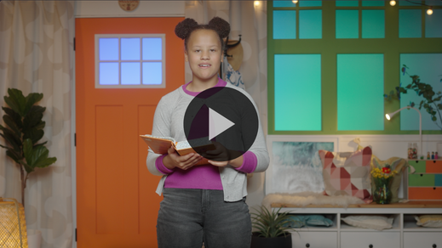

In our Faith Verse, Paul was telling the people in the church how to stand strong. He said, “Put on every piece of God’s armor so you will be able to resist the enemy in the time of evil. Then after the battle you will still be standing firm.” That’s a really long verse! Let’s practice it now, but we’ll just focus on the first part today. We’ll learn the rest of the verse later.

**Ephesians** *(hands at waist, spread apart, palms up and out)*

**6:** *(hands together like a clap)*

**13** *(hands opened to “book”)*

**Put on every piece** *(bring one arm crosswise to pat opposite arm and repeat with other arm)*

**of God’s armor** *(pretend to put on helmet)*

**so you will be able to resist** *(cross forearms together in front)*

**the enemy in the time of evil.** *(put arms out like showing strong biceps)*

What a great reminder that God helps us stand strong no matter what! Thanks for learning our Faith Verse with me.

**Closing**

What a great time we’ve had together! Did you learn more about God today? *(Group response)* We’ve worshipped Him by singing and praying. We’ve learned a Faith Verse from the Bible. Now, *(scratch head like thinking)* who did we learn about today from the Bible? Was his name Stuart? Stefan? *(Group response)* Oh, right. It was Stephen. You all are such great listeners and such great students of the Bible.

• *Play the* ***Faith Fact Sound*** *video (bell ringing).*

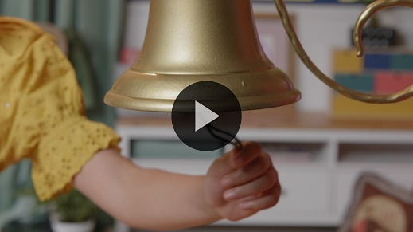

That sound means it’s time to practice our Faith Fact one more time. **I will serve God no matter what**.

• *Show the* ***Faith Fact Slide.***



Let’s say our Faith Fact with those strong voices we warmed up already. Ready? **I will serve God no matter what**. Now, let’s stand as strong as we can. Put our feet apart and make our arms strong *(demonstrate)*. Now, say the Faith Fact. **I will serve God no matter what**.

**Dismissal to Small Groups**

Great job! It’s time to go to our circles where we’ll spend time in our very special small groups.

• *Dismiss the kids by groups.*

|  |
| --- |
| ***Leader Tip:*** *This can be done by assigning color teams or by age groups. Note that some young preschoolers may not know their age. Using a colored sticker, jersey, or wristband will help separate the kids and help identify their small groups.* |

**Small Group**

**25 Minutes**

*See supplies and prep instructions at beginning of session or in each activity below.*

|  |
| --- |
| ***Leader Tip:*** *Small groups can alternate to each circle, or all groups can do each activity at the same time. If you choose to alternate, you will need at least one leader per circle.* |

**Circle 1**

**Group Connection**

**Serving You**

|  |
| --- |
| ***You Will Need***  *• Paper plate or bowl, one per group*  *No prep needed for this activity.* |

Raise your hand if you have a good imagination. *(Group response)* Awesome! I need each of you to close your eyes and imagine your favorite food.

• *Pause while kids close their eyes.*

Picture your favorite food in your mind. I want you to think about where you like to eat that food. It might something special you eat at home. Maybe you go to your favorite restaurant. It could even be a special treat that your grandma or someone else makes when you visit them. When you know what your special food is, open your eyes. (*Group response)*

• *Hold up the plate.*

When you eat food, what does your food go on? *(Group response)* That’s right, a plate or bowl. We’ll take turns passing this plate around the circle. When you’re holding the plate, I want you to turn to the next person and say, “What can I serve you?” When your neighbor asks you that question, you’ll answer, “I’d like ___________.” Fill in the blank with your favorite food. When you give the plate to your neighbor, say, “Here you go!” When you take the plate, do you know what to say? *(Allow responses.)* That’s right, we should say, “Thank you!” Let’s serve together.

• *Guide kids as they pass the plate and talk about their favorite foods.*

Thanks for sharing about your favorite foods. This time we’ll change it up. When the plate gets to you, I want you to tell us who makes your favorite food or where you can get it from. Let’s go!

• *Pass the plate around the circle again and encourage kids to share.*

Doesn’t it make you happy that somebody takes the time to make your favorite food for you? *(Group response)* Whether it’s someone in your family or someone at a restaurant who makes your favorite food, they are serving you. Wait! Serving reminds me of our Faith Fact. Let’s say it together. **I will serve God no matter what.**

**Circle 2**

**Activity Page Time**

**I Can Serve Others**

|  |
| --- |
| ***You Will Need***  *•* ***Small Group Activity Page****, one per kid*  *• Pencils or pens, one per kid*  *• Crayons or markers*  ***Getting Ready***  *• Print copies of the* ***Small Group Activity Page****, one per kid.* |

Today, we learned that we can serve God no matter what. Stephen served God by helping others. We can do that, too.

• *Hand out a copy of the* ***Small Group Activity Page****, a pencil, and crayons to each kid.*

Look at the pictures on your page. I’ll read the sentences about each picture.

• *Read the statements with each picture.*

Hmm. I think there might be something wrong. Does each picture show someone serving or helping others? *(Group response)* You’re right! Can you cross out the picture that doesn’t go with the others?

• *Pause while kids cross out the picture of the boy in a messy room.*

Let’s look at the other pictures. There are many ways we can serve others like Stephen did. Next, I’d like you to circle the pictures that show ways you can help others. God loves it when we serve others.

• *Talk with kids about the pictures and how each person is serving.*

• *Let them share about how they serve others.*

• *Have them color the pictures as time allows.*

• *During the activity, interrupt and practice the Faith Fact:* **I will serve God no matter what.**

• *Play the* ***Faith Fact Sound*** *video. Review the Faith Fact even if you can’t play the sound.*



**Circle 3**

**Feet-to-Floor Game Time**

**Obstacle Overcomer**

|  |
| --- |
| ***You Will Need***  *• Optional: Cones or floor-safe tape to mark off play space*  ***Getting Ready***  *• Optional: Place cones or use floor-safe tape to create a play space. This should include a start and stop line as well as boundaries to stay within.* |

Who wants to play a super fun game? *(Group response)* Oh, yeah! This will be great. Today, we learned that Stephen had to overcome some hard things while he served God. He never let the obstacles in front of him keep him from the plans that God had for him. For today’s game, all of you will stand on one side of the playing area. I will need two of you to be “It.” You will have a very special job. When I say go, everyone will try to go from one side of the room to the other. The people who are It will try to tag you. Let’s play.

• *Play until someone gets tagged. Then, pause the game.*

Good news! When you get tagged, you’re not out of the game. Just because something bad happened to you, it doesn’t mean you’re out. You can keep playing, but you will be playing a little differently. After you get tagged, you’ll sit down and use your hands to tag anyone who comes near you. Each time you tag someone, I want you to say our Faith Fact**: I will serve God no matter what**. That will remind you that even when hard things happen, you can keep serving God. We’ll keep playing until everyone gets tagged.

• *Allow kids to play for as long as time allows. If possible, play a second round.*

• *Occasionally yell, “Freeze,” and have everyone pause and say the Faith Fact together.*

That was amazing! I don’t know what was more exciting to watch—those of you running across the room or the ones trying to tag everyone. What I loved is that no matter what was happening, everyone still had a job to do. You could keep serving no matter what.

**Circle 4**

**Hands-On Learning**

**Ripple Effect**

|  |
| --- |
| ***You Will Need***  *• Marbles or coins, one per kid*  *• Clear plastic bowl, one per group*  *• Water*  *• Larger pan under bowl in case of spillage*  ***Getting Ready***  *• Fill the bowl with water.* |

When we know God’s Word, it’s so much easier to serve Him. Who can tell me the name of the man who served God in our Bible story today? *(Allow responses.)* That’s right. It was Stephen. He was chosen to serve food to people who needed it.

• *Point to the bowl.*

He also told people about Jesus. No matter how others responded, Stephen never quit serving God. In fact, he made such a big impact telling others about Jesus that we are still talking about him today. Raise your hand if you want to serve God like Stephen. *(Group response)* When we serve God, it’s kind of like this.

• *Hold up the marble. Then, drop the marble in the center of the bowl.*

Did you see how the marble made a splash and a few waves or ripples when I dropped it in? *(Group response)* You see, when we serve God, many times that means we’re serving other people, too. Every time we meet someone, we have the opportunity to create waves in their life. When we have a heart to serve God, we want people to feel His love.

• *Drop a few more marbles in at one time and react wildly to the splashes and ripples they make.*

God wants everyone to serve Him by serving others like Stephen did. When we do that, we’ll all make ripples of God’s love in people’s lives. Does anyone want to help me drop a few more marbles in the water to show what that’s like when we all work together? (*Group response)* Awesome! I was hoping you would!

• *Allow each kid to drop a marble into the water and watch the impact.*

That was great! I want you to remember that you don’t have to wait until you’re a grown-up to serve God and show His love to others. You can start serving Him now and making waves everywhere you go.

**Dismissal**

• *Play the* ***Faith Fact Sound*** *video (bell ringing).*



• *Show the* ***Faith Fact Slide.***



Wow! It has been a great day, and I’ve loved learning with you. I’m so excited to see how God is going to use you in the world around you. I’m even more excited that so many of you raised your hands and said that you want to serve God. Before we go, let’s say the Faith Fact together one last time. **I will serve God no matter what.** Great job! See you next time!

• *Send home the* ***Small Group Activity Page*** *with each kid.*

• *Remind parents that there are* ***Family Devotions*** *available on the app to do with their kid.*

• *Tell everyone the date and time for the next session.*